Mrs. Nicol’s Class Party Sign Up Sheet
You are welcome to sign up for one party. I will send a reminder note when it close to the party you signed up for. Thanks in advance!
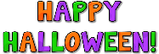
Halloween
apples and caramel | Ethan
baggies of popcorn | Lylian
rice krispie treats | Jayden O.
juice bags or boxes | Rylie
plates and napkins | Benjamin
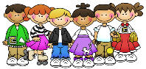
50th day of School
2-2 liters Root beer | Twanette
tub of vanilla ice cream

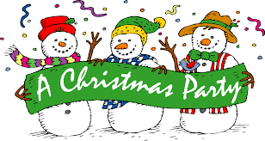
Christmas
nachos and salsa
ice cream sandwiches or cups | Chloe
cupcakes | Bella
juice bags or boxes | Nathan
plates and napkins | Dawson
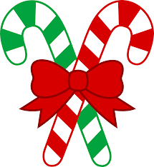
Christmas Craft Day
2 dozen unfrosted cut-out cookies | Liam
2 dozen unfrosted cut-out cookies
2 dozen unfrosted cut-out cookies | Caradee
30 juice bags or boxes | Jayden B.
30 juice bags or boxes | Kayden
Literacy Luau
fruit tray | Eliot
baggies of goldfish crackers | Brooke
juice bags or boxes | Joshua
Plates and napkins | Kendall
Valentine’s Day
red finger jello | Katelynn
cookies | Devyn
veggie tray
juice bags or boxes | Mya
plates and napkins | Laurie

