Accelerated Reader
Where can your child take an A.R. test?
- You are welcome to help your child with an A.R. test before or after school in our school library or in our classroom (most days). Please let me know if you need assistance.
- You are also welcome to help your child with an A.R. Test at the Marlette District Library (989.635.2838). Marlette District Library Hours: Mon./Wed./Fri: 9-5, Tues./Th.: 10-6, Sat.: 10-2
How do you look up your child’s A.R. records?
Step 1: Go to marletteschools.org website: Click on Elementary tab and then Accelerated Reader Tab.
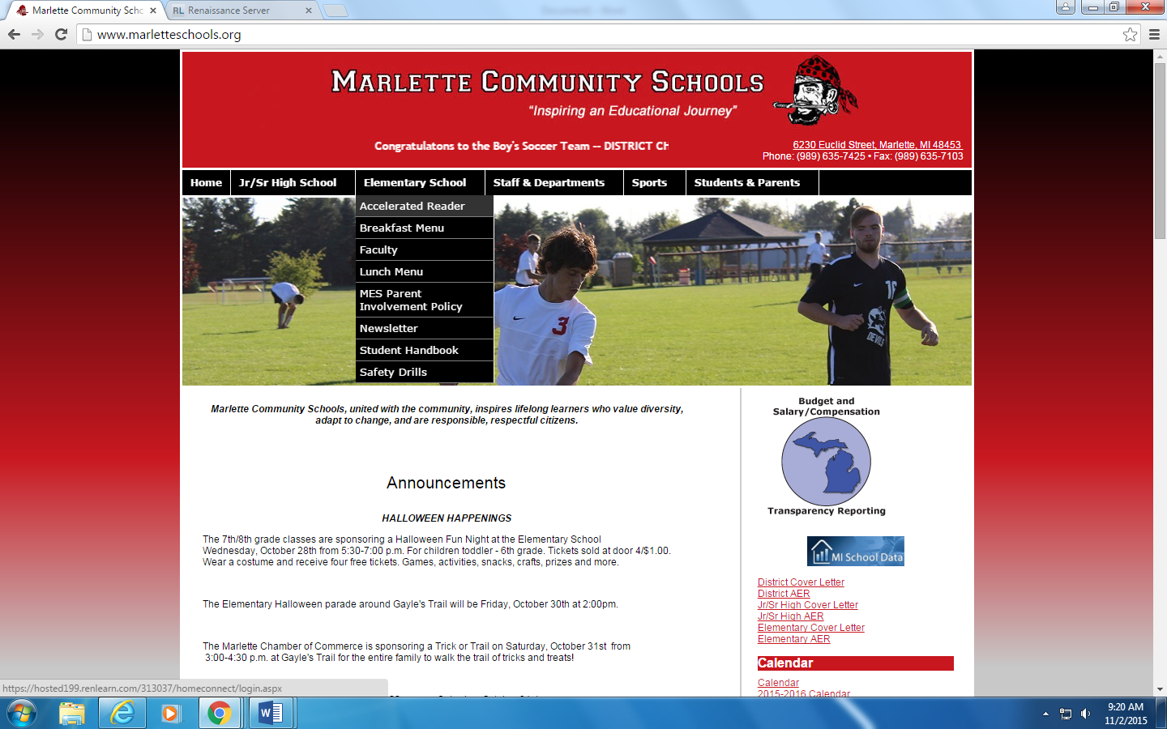
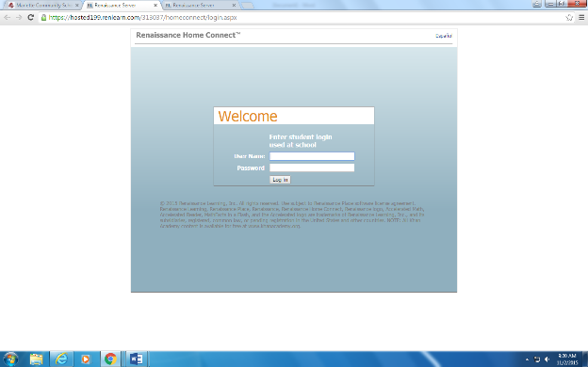
Step 2: Log in to your child’s acct: first name space last name. Your child’s password is their initials.

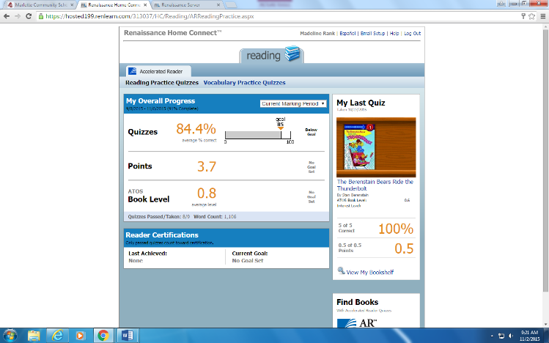
Step 3: You should be able to see the books read and the % on the tests taken.

How do you tell if a book is an A.R. Book?
- Go to arbookfind.com book.
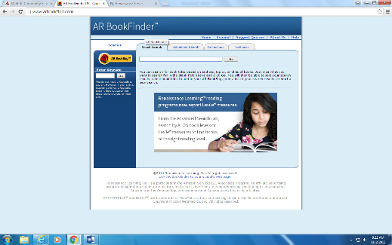
- Select parent and then type in the title of the book.
- It will tell you if the book is an A.R. Book and what the book level is.

