Mrs. Nicol’s First Grade Schedule
8:00-8:15 | Morning Warm Up: Spelling
8:15-8:30 | 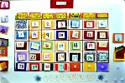  Calendar
8:30-8:45 | Spelling
8:45-9:00 | Making Words/Extended Text  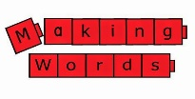
9:00-10:00 | Readers Workshop Rotations
10:00-10:10 | Bathroom Break and Brain Break
10:00-10:50 | Science
10:50-11:10 | Walk
11:15-11:50 | Lunch and Recess
11:50-1:00 | Math
1:00-1:45 | Special  Computers Art Gym
1:45-2:00 | Snack/Daily Jobs
2:00-2:30 | Social Studies
2:30-3:00 | MTSS
3:00 | Wrap Up: Good-bye
3:05 | Dismissal

